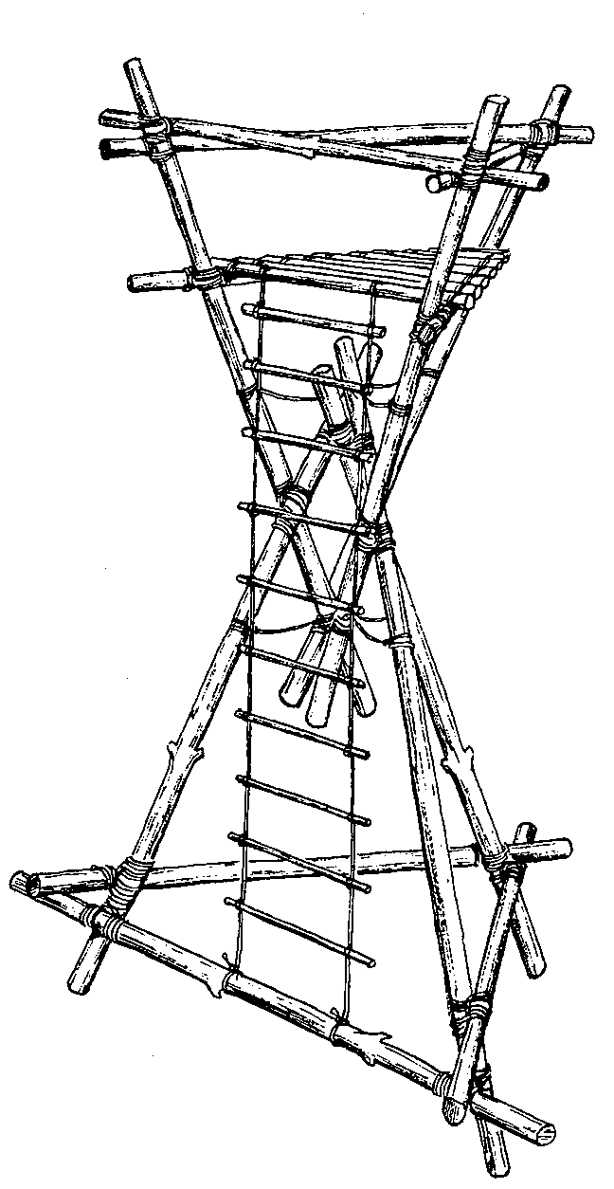
Hour Glass Tower

The tower is constructed from two large pyramids interlocked together. It must be built on its side then raised vertically with the aid of an additional tripod of spars.
Care must be taken to ensure that all the equipment used is in excellent condition and that the lashings are really tight.
We recommend that you make a model from garden canes first as this will help you to see where things are meant to go and how the tower fits together – everything looks very different when lying on its side!

Equipment
- 9 x spars 3.6m long
- 6 x spars 2.5m long
- 2 x spars 2m long
- 10 x light spars for the platform
- 26 x lashing lengths
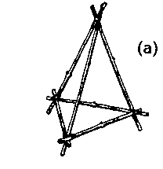
- 3 x ropes 15-25m long for raising the platform
- 1 pulley suitable for the above rope
- Guy ropes
- additional ropes for the platform
- 1 ladder/rope ladder

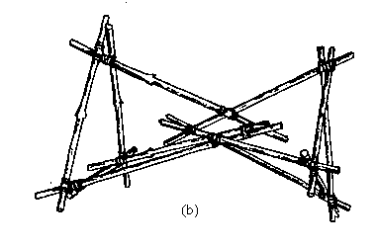
Method
- Using 3 x 3.6m spars and a figure of 8 lashing, build a tripod.
- Using square lashings, fix 3 x 2.5m spars across the butt ends. (a) This is the base unit – lay it on its side.
- Prepare a second tripod with 3 more 3.5m long spars.
- Feed one leg of the tripod through the apex of the base unit. Complete the top unit by lashing 3 x 2.5m spars close to the butt ends – this will form the handrail. (b)
- Once the frames have been positioned correctly, lash the main spars together using square lashings. Note: although the spars cross at an acute angle, you must use a square lashing.

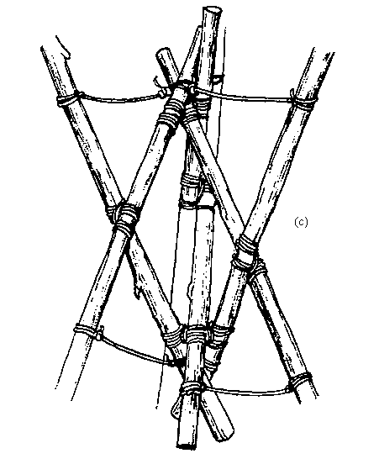
- Add additional strength by lashing the apex of each tripod to the opposite main spars using a round turn and two half hitches. (c)
- Build a tripod using the remaining long spars and hang the pulley to its apex. Position this about 10m from the tower. Fix the long ropes to the apex of the base unit and feed the upper one through the pulley – the other two ropes are used to keep the tower steady as it is raised.
- Once the tower is upright, check that the top is level. Lower it again and make any necessary adjustments.
- While the tower is horizontal, fit the platform by lashing the 3 x 2m spars about 1m below the handrail and lashing the light spars across them.
- Attach the rope ladder to the platform and the lower horizontal spar.
- Attach guy ropes to the main spars above the hand rail.
- Raise the tower.
Hour Glass Tower

